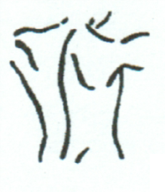
McKENZIE TOWNE CHIROPRACTIC

AND MASSAGE

PATIENT ENTRANCE FORM

Name: ______________________________________________ Date: _______________________
Address: ________________________________________________________________________
City: ________________________ Province: _______________ Postal Code: ________________
Home Phone: ________________________ Cell Phone: ____________________________
E-Mail Address: ____________________________________ (for appointment reminders and/or receipts)
Date of Birth: (DD/MM/YYYY) _________________________ Gender: M / F
Occupation: ______________________________ Employer: ____________________________
Marital Status: single married common law divorced widowed
Prov. Health Card #: _____________________
Do you have a Benefit Plan? Yes No Benefit Plan Name: ________________________
Plan#_________________ Member#___________________
How did you hear about our office: friend ________________________________
website sign Facebook other______________

Emergency Contact: __________________________________ Phone: ______________________

*The clinic is aware of the sensitivity of your personal information and your personal information will not be released to any other party without appropriate authorization from you.
**The clinic collects certain information for the purpose of providing diagnostic, treatment and care services, and will only collect, use and disclose your health information in accordance with the provisions of the Health Information Act.

Have you had previous chiropractic care? Yes No
Dr.____________________________ Date__________________

Medical doctor: Dr._____________________________ Date of last visit:______________________

Reason for appointment today: _______________________________________________________
When did your condition begin? _______________________________________________________
Have you ever had a similar problem? Yes No
Have you had x-rays, MRI, or other tests for this condition? Yes No
If Yes, which tests and when____________________________________________________
Is this a work related injury/accident: Yes No
Is this a Motor Vehicle Accident (MVA)? Yes No

Patient: _______________________________

Please mark the areas where you have pain or unusual feeling. Use appropriate symbols:

Numbness Pins & Needles Burning Aching Stabbing
••••• 00000 xxxxx ***** /////

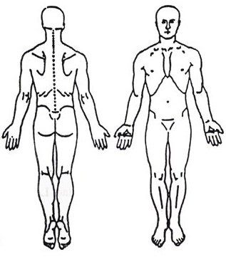
Please indicate the severity of the pain by circling a number.
0 1 2 3 4 5 6 7 8 9 10
No Pain Extreme Pain
Health History Questionnaire

Have you ever been diagnosed or told you have any of the following? Please circle the correct response.

- High blood pressure……………………………………………………… Yes No
- Hardening of the arteries (arteriosclerosis)…………………… Yes No
- Diabetes………………………………………………………………………. Yes No
- Tuberculosis…………………………………………………………………. Yes No
- Cancer……………........................................................................ Yes No Where: ______________
- Heart or blood diseases……………………………….……………….. Yes No
- Arthritis………………………………………………………………..………. Yes No
- Whiplash injury (flexion-extension injury, cervical sprain) Yes No Date: ________________
- Have you or any of your relatives ever suffered a stroke? Yes No
- Any other accidents, injuries, fractures (What & When?) Yes No Date: ________________
______________________________________________________________________________________
- Were you ever a smoker?.................................................... Yes No
- Please list medications___________________________________________________________________
_______________________________________________________________________________________

Patient: _______________________________

Please check any conditions that are presently causing you a problem, as well as those that have caused you problems in the past.

GENERAL SYMPTOMS RESPIRATORY GENITOURINARY
Past Present Past Present Past Present

  Fever   Chronic coughing   Frequent urination
  Sweats   Spitting up phlegm   Painful urination
  Sleep disturbances   Spitting up blood   Blood in urine
  Fatigue   Chest pain   Kidney infection
  Nervousness   Wheezing   Prostate trouble
  Weight loss   Difficulty breathing
  Weight gain   Asthma

NEUROLOGICAL CARDIOVASCULAR GASTROINTESTINAL
Past Present Past Present Past Present

  Visual disturbance   Rapid beating heart   Poor appetite
  Dizziness   Slow beating heart   Difficult digestion
  Fainting   High blood pressure   Heartburn
  Convulsions   Low blood pressure   Ulcers
  Headache   Pain over heart   Nausea
  Numbness   Hardening of arteries   Vomiting
  Neuralgia (nerve pain)   Swollen ankles   Constipation
  Poor coordination   Poor circulation   Diarrhea
  Weakness   Blood clots   Blood in stool
  Bruise easily   Gallbladder/jaundice
  Varicose veins   Colitis
  Aneurysm

EENT MUSCLE & JOINT FOR WOMEN ONLY
Past Present Past Present Past Present

  Eye pain   Neck pain   Painful menstruation
  Double vision/blurring   Low back pain   Hot flashes
  Deafness   Arm pain   Irregular cycle
  Nosebleeds   Shoulder pain   Cramps or back pain
  Trouble swallowing   Leg pain   Lumps in breast
  Hoarseness   Knee pain   Menopausal symptoms
  Sinus infection   Foot pain   Birth control pills
  Pain/numbness down   Miscarriages
Arms or legs   Pregnancy complications
  Pain between shoulders   Pregnant Yes / No
  Swollen joints
  Spinal curvature/ Scoliosis

